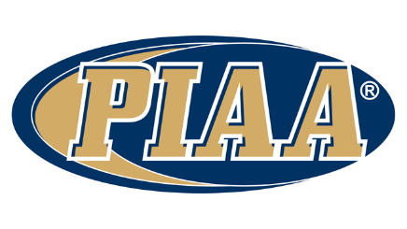
Official league roster – VARSITY GIRLS Soccer
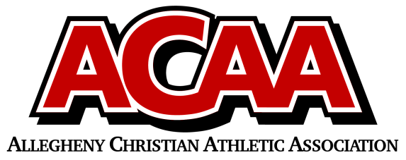

School Name: Meadowbrook Christian
Team Colors: White and Green
Overall Wins ___ Losses ____ Ties ___
ACAA Wins ___ Losses ____ Ties ___ OPPONENT: __________________________
Date: _________

Number | Name | Year | Position | Homeschool
38 | Abby Bingaman | 12th | Striker
17 | Kailey Devlin | 12th | Mid
31 | Audrey Millett | 12th | Striker
11 | Maddy Osman | 12th | Defender
2 | Macey Feick | 11th | Mid/Defense
16/00 | Emma George | 11th | Mid 16/ Keeper 00
35 | Haileyanne Kramer | 11th | Mid/Defense
12 | Abby Schuler | 11th | Mid
4 | Angelina Trego | 11th | Striker/Mid
25 | Grace Skjodal | 11th | Striker/Mid
26 | Grace Ask | 10th | Defense
13 | Kat Bennage | 10th | Mid
32 | Melanie Eager | 10th | Defense
14 | Madalyn Fasnacht | 10th | Striker
24 | Sarah Hecker | 10th | Striker
7 | Erica Stauffer | 10th | Mid/Defense
5 | Addie Haas | 9th
39 | Faith Lubold | 9th
45 | Chloe Miller | 9th
6 | Hannah Millett | 9th

Co-Head Coach: Brian Osman
Co-Head Coach: Bill George
Asst. Coaches: Greg Clendaniel
Abby clendaniel
Ryan Kuhns
Student Coach: Alayna Smith
Athletic Director: sAMANTHA DELONG

Official ACAA League Team Roster. to be submitted to the scorer’s table before each game.

